**Sample questions UGCA F2018 Set II**

1. Over time you kept on adding people to follow on Twitter without a careful assessment. One day you realized you were following 1000 people, and that it’s time to trim the list to be able to receive what really matters to you. You are looking for interesting and new information through Twitter that you may not easily get elsewhere.

Discuss two types of people you would like to stop following. How would you identify such people through metrics? Do not identify people by the type of messages they send. Instead, describe their network characteristics and justify why you would stop following them.

2. Consider a clustering exercise of 100 movies based on their synopses (using tf-idf scores and 5 clusters). Each cluster is identified by a specific color. Based on the cosine similarity between the movies, we also draw the MDS plot of the movies as shown below. Assuming that the MDS plot is accurate, did clustering do a good job? Justify your response.

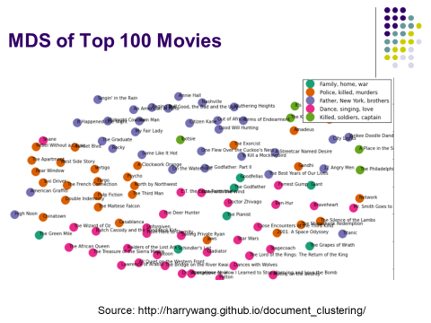

3. One brand X provides short captions for its Instagram image posts, while another brand Y provides more details in its captions. Both brands currently use captions in a classification model to predict high/low engagement. If they also performed image analytics and then added the labels to the caption words, in which case (X or Y) will there be more improvement in predictions using captions + image labels? Why?

3. Discuss the general characteristics of a customer with high Customer Network Lifetime Value (CNLV).

1. *High CNLV customers* ***engage with your brand****. While it is tempting to only count your devoted “fans”, it is just as important to pay attention to people who feel a strong connection to your brand and who may provide critical but useful feedback. E.g., if somebody is unhappy with your service but takes the time to write a long note, s/he should be taken seriously.*
2. *They are* ***willing*** *to recommend your product or services. There may be fans who are not socially active or willing to pass the word around (they are not useful for you)*
3. *They are* ***influential*** *in their network. It is a common mistake to assume that popularity = influence. Just because people like or comment on someone’s posts or pictures may not mean that their actions are influenced by this person.*
4. *Have a* ***large network*** *and be* ***favorably positioned*** *in the network. An influential person located at the corner of a network may have limited impact as such influence will get attenuated by the time it reaches the other corner of the network.*